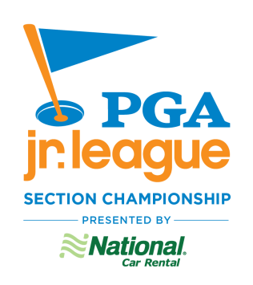

SPECTATOR CONDUCT EXPECTATIONS
- Spectators acknowledge that the goal of PGA Jr. League is for players to have fun with friends
- Spectators are encouraged to cheer, have fun and be supportive of all players
- Spectators agree to stay on the cart path at all times
- Spectators agree to refrain from having any contact with players during play of a match Spectators agree to defer the review and enforcement of rules decisions to team Captains and PGA Jr. League Officials. Failure to do so results in the first offense being a warning and the second offense being loss of the hole
- Spectators agree to abstain from caddying
- Spectators agree to demonstrate sportsmanship, respect and a positive attitude
- Spectators agree to abide by any rules and regulations of the host facility (dress code, cell phone policy, spectator policy, etc.)
- Spectators agree not to argue with other spectators, players, Captains, Coaches, host facility staff or PGA Jr. League Officials. Failure to comply will result in the immediate removal of the individuals involved for the remainder of the competition
  - Zero tolerance
  - No warnings will be issued

